

DIGITAL MARKETING PROJECT

CREATING BLOG USING WORD PRESS PLATFORM

**NM id : B3F06510CC0EBC5993B4F4A42F3EACD1**

# Submitted By:

1. DHANASREE S AU613020104014

1. DHARANI R AU613020104015
2. GAYATHRI A AU613020104019
3. MYTHILY M AU613020104051

**BE – Computer Science and Engineering Vivekananda College of Technology for Women Namakkal - 637205**

# BRAND NAME :

Style fusion

# LOGO :



1. **CATEGORY :**

Clothing brand

# EMAIL :

Stylefusion1923@gmail.com

# TARGET AUDIENCE :

Exclusive for Womens

# TARGET LOCATION :

Coimbatore , Tamil Nadu, India

# WEBSITE FOR BRAND :

<https://stylefusionin.wordpress.com/2023/10/24/style-fusion/>

# PROJECT STEPS :

**Step 1:** Click get started button

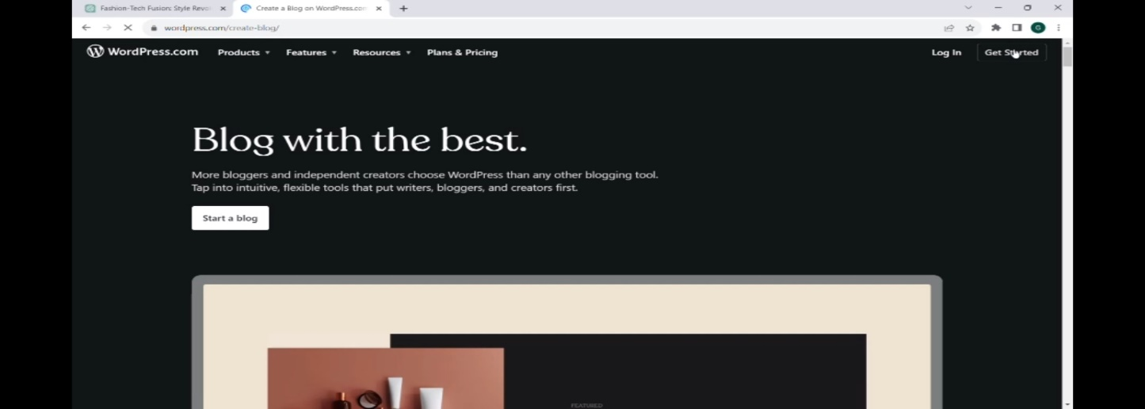

**Step 2:** Create new google account for blog

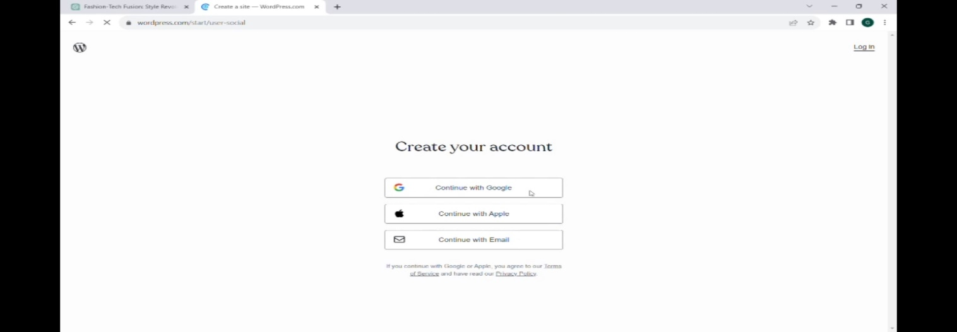

Step 3: Choose a Domain for a blog

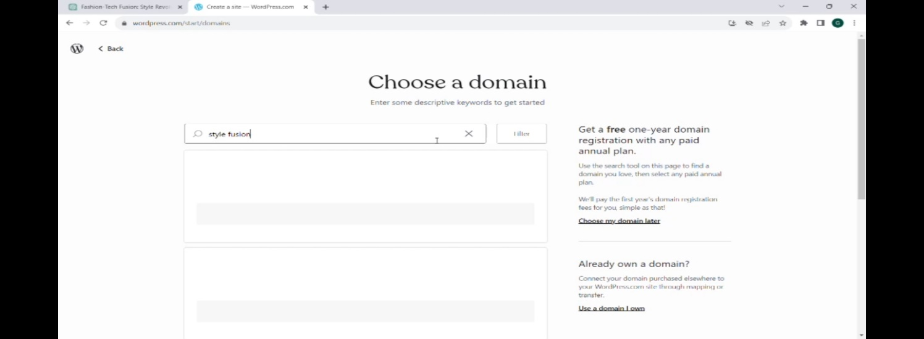

Step 4 : Choose the flavor of WordPress

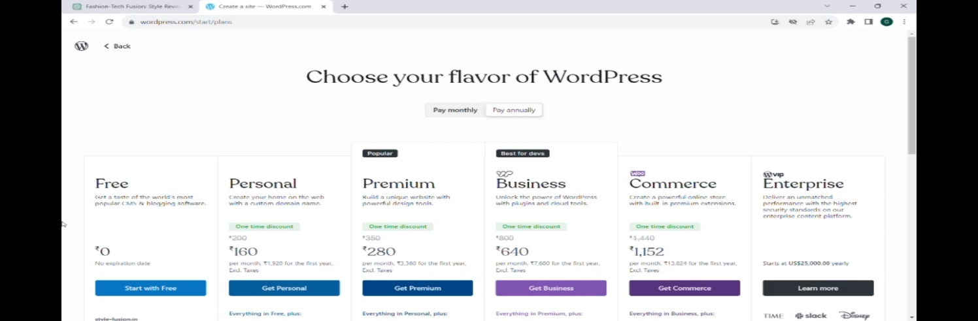

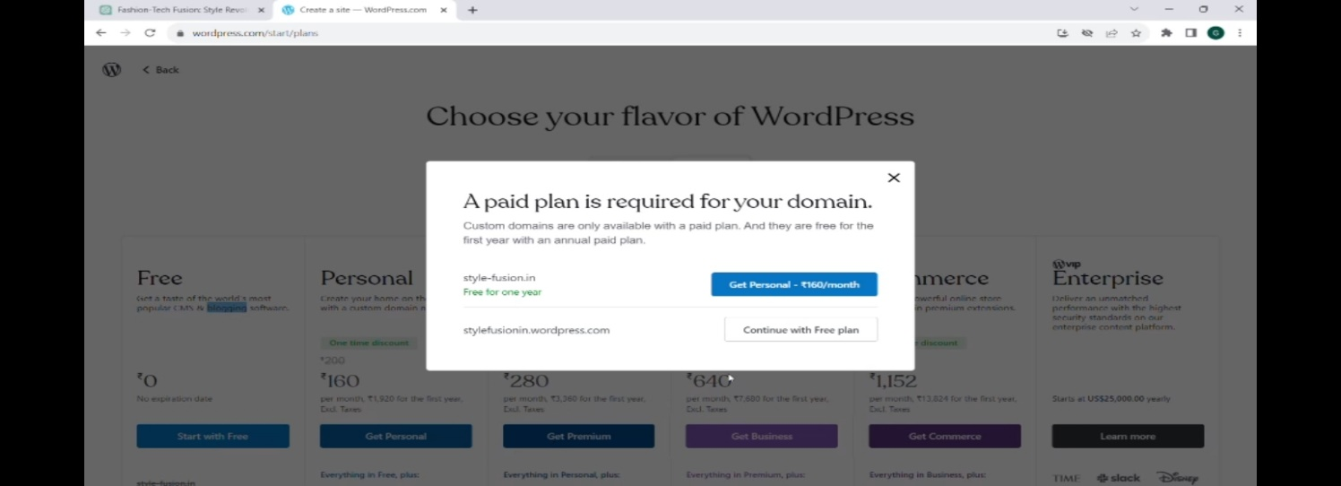

Step 5:Create a new site for blog

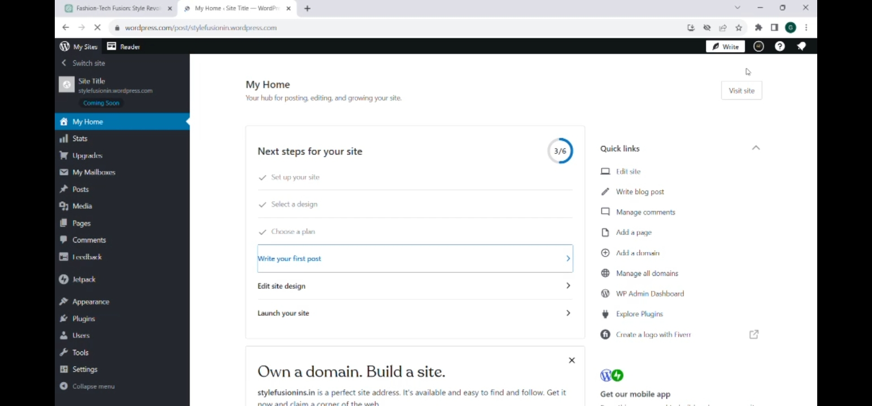

Step 6: Posts – Add new posts

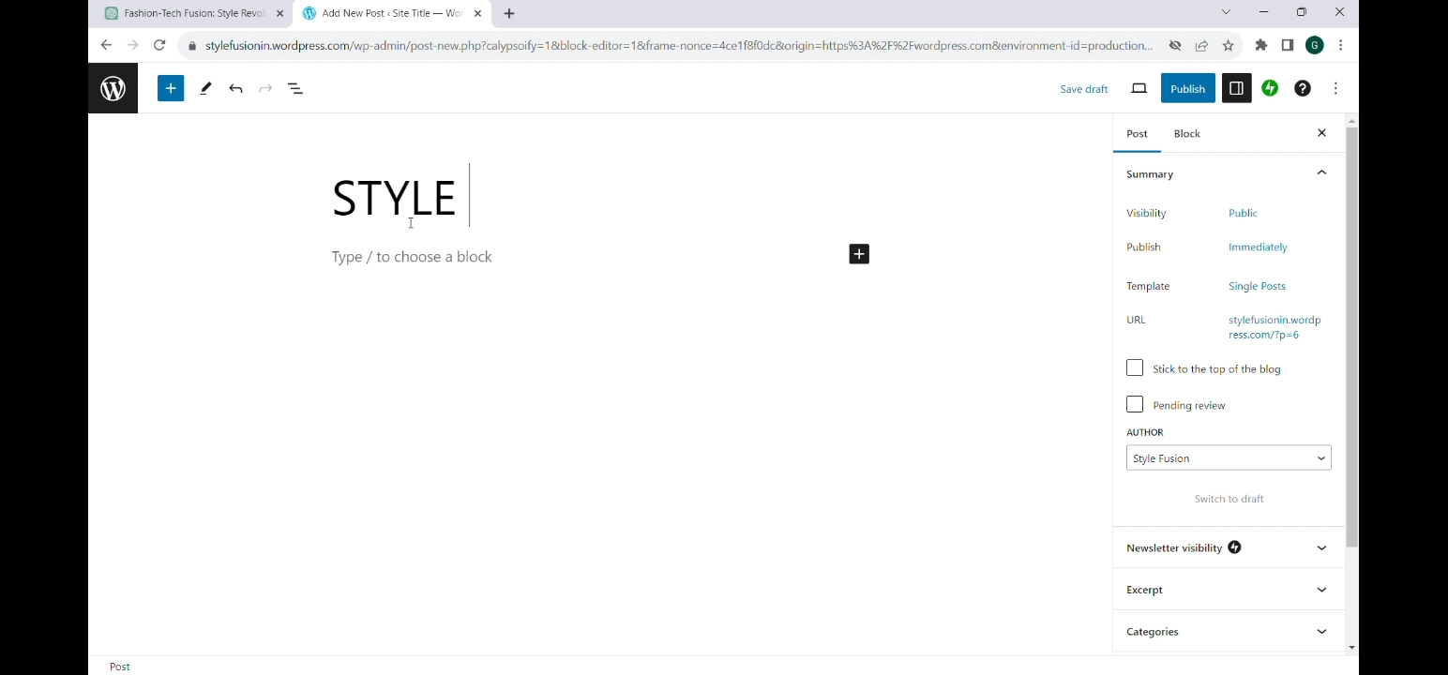

Step 7 : Sign up and login the AI and click here and type the blog title , after that click copy.

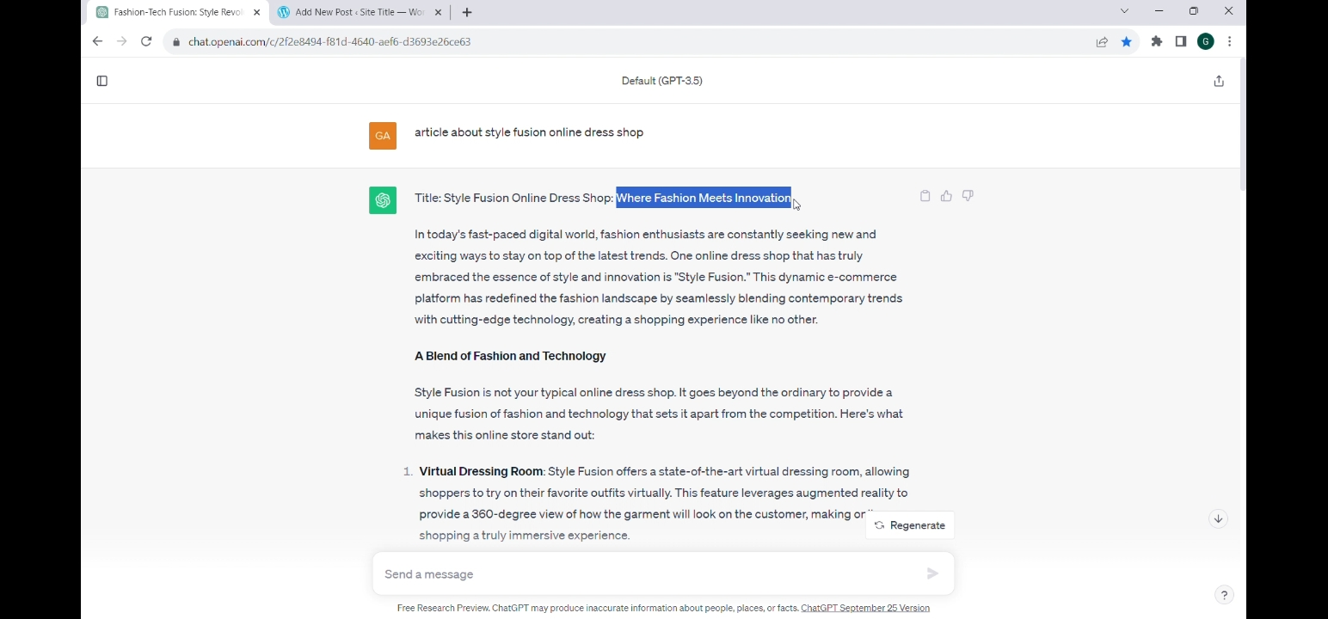

Step 8:Click new and paste the Blog you copied Earlier from copy AI

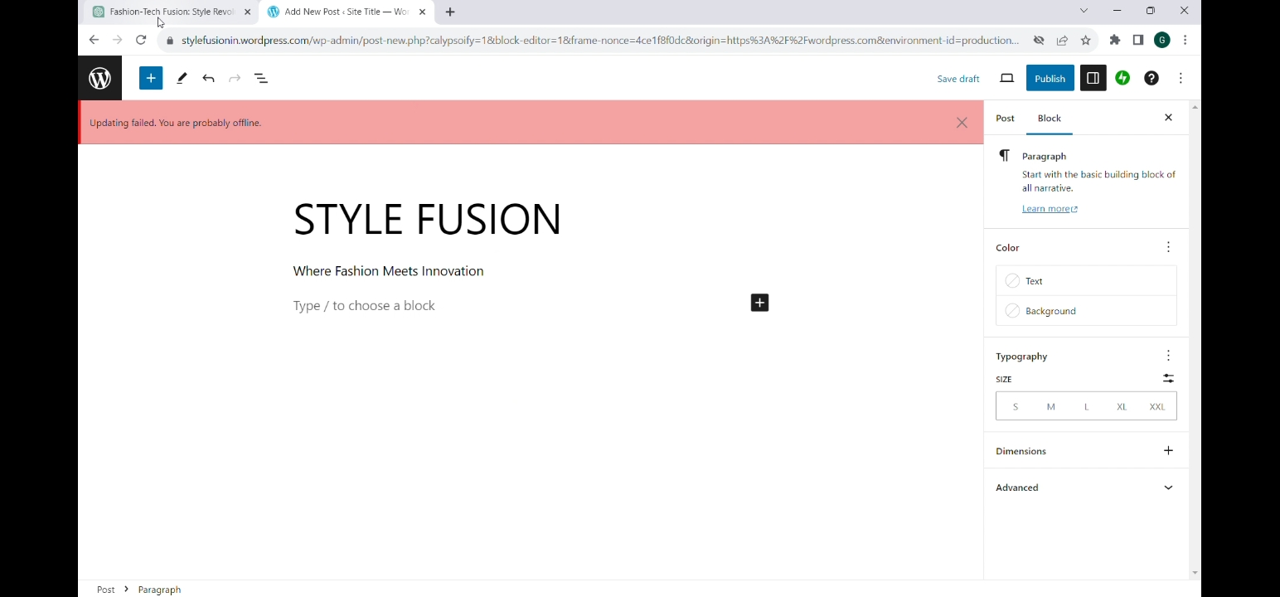

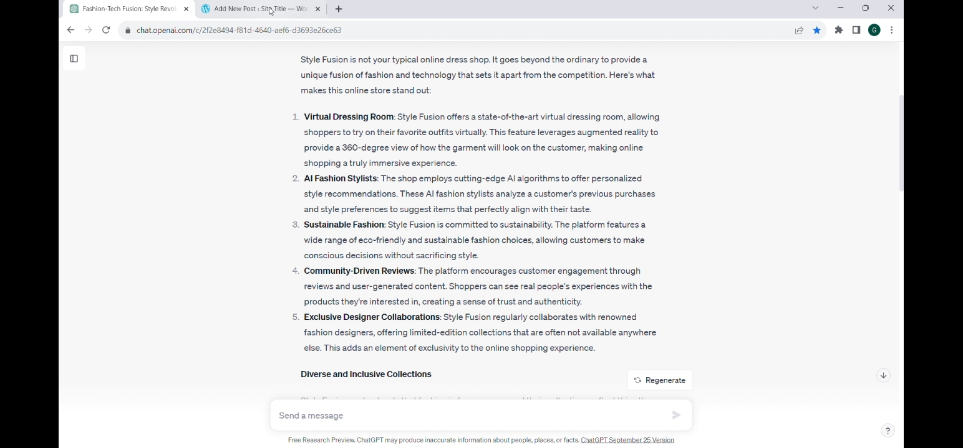

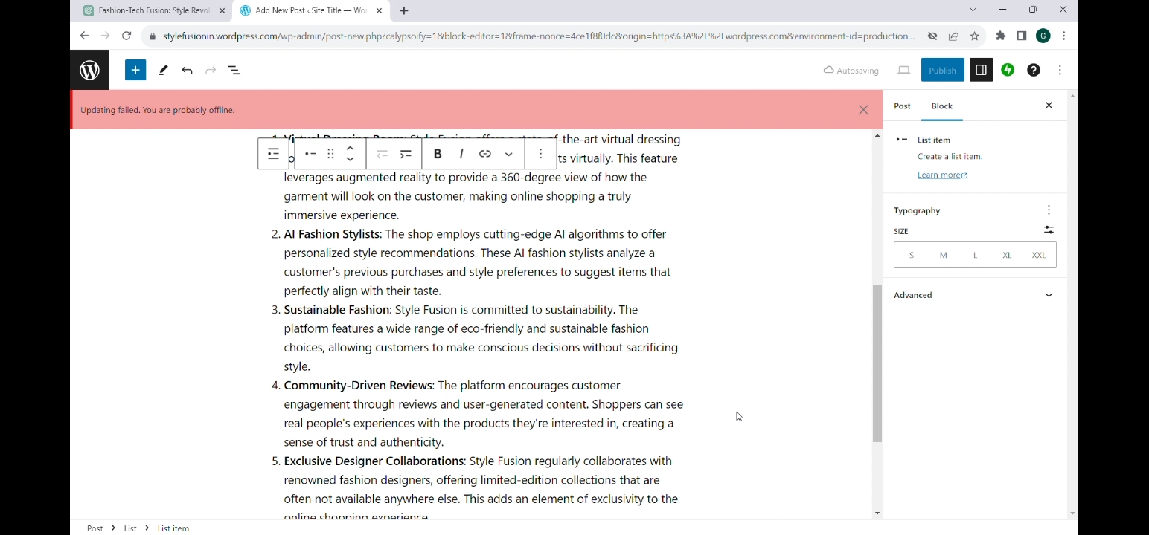

Step 9 : Set goals and check Grammer

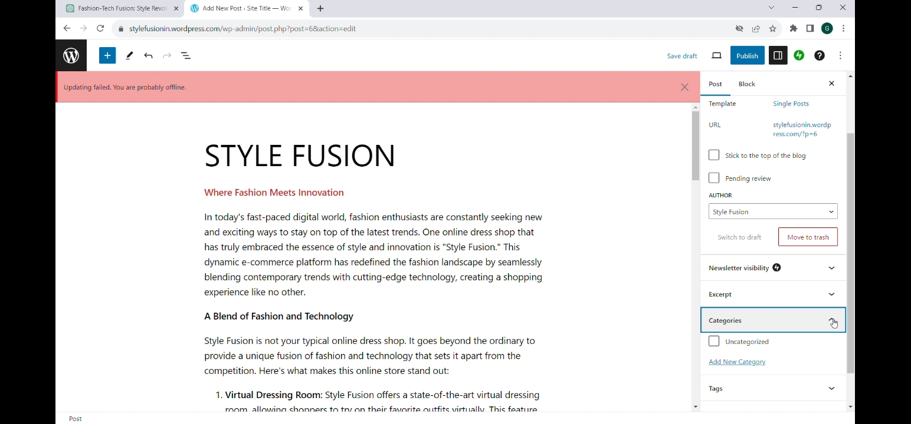

Step 10 : Now copy title and paste it in your blog

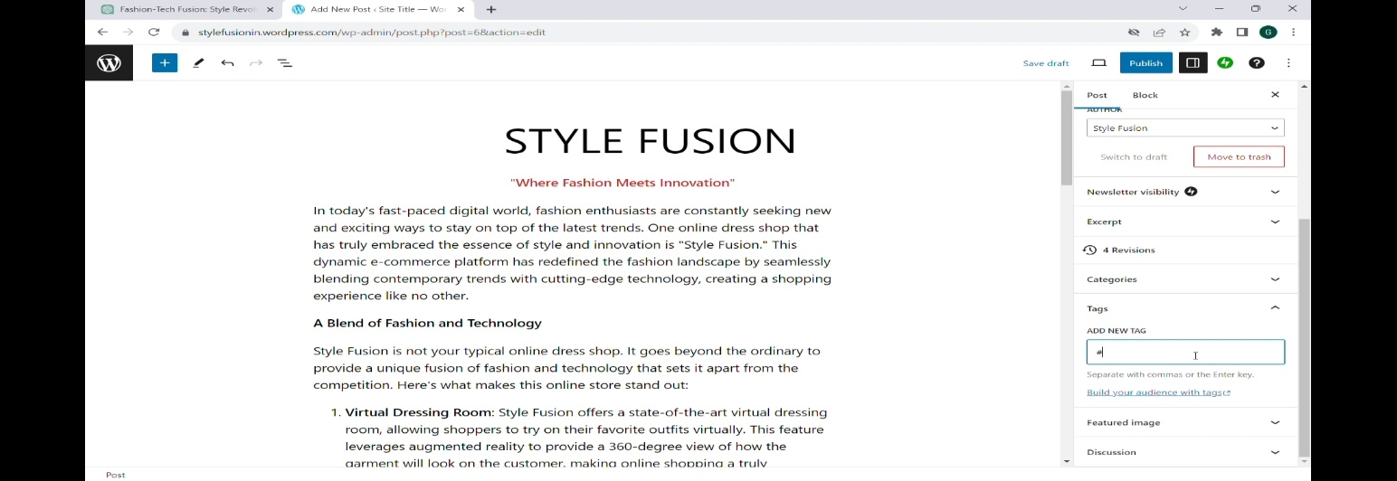

Step 11 :Click the settings button , Scroll down and add captions,Tags,Title ,Description, and Featured image to the blog.

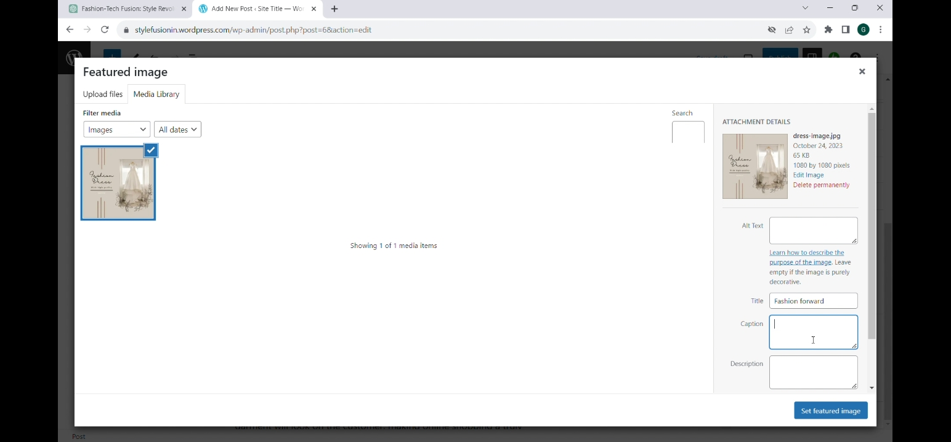

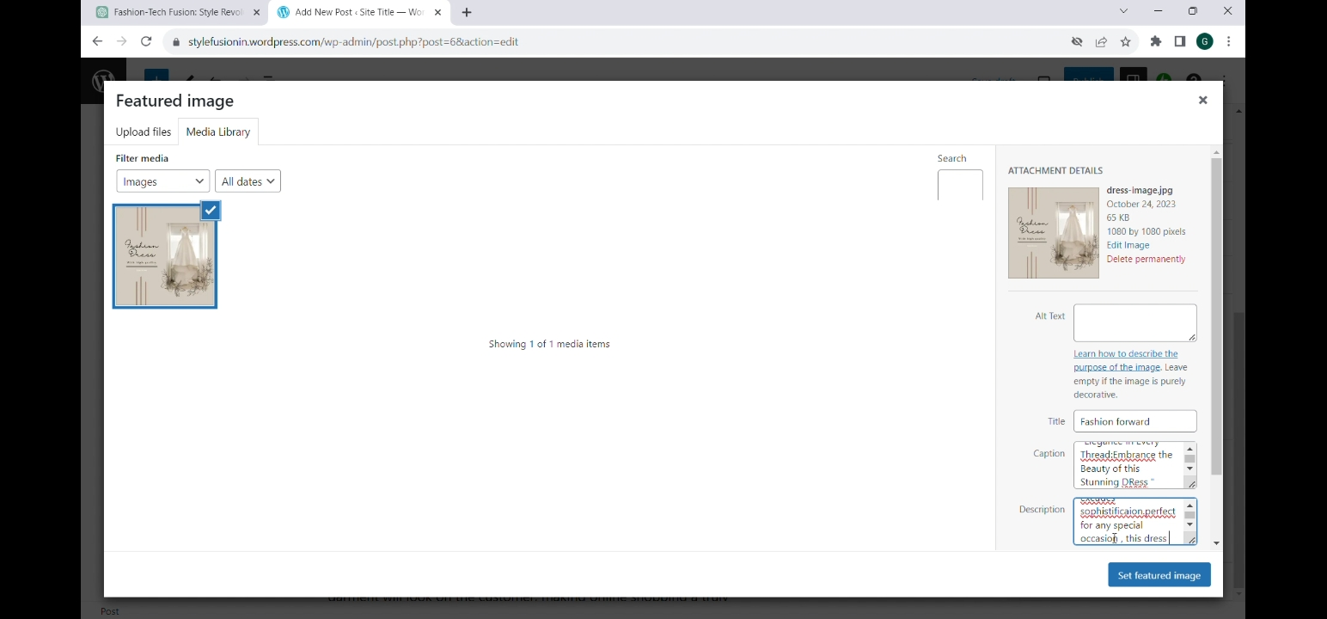

Step 12 : After full Editing it and click publish button.

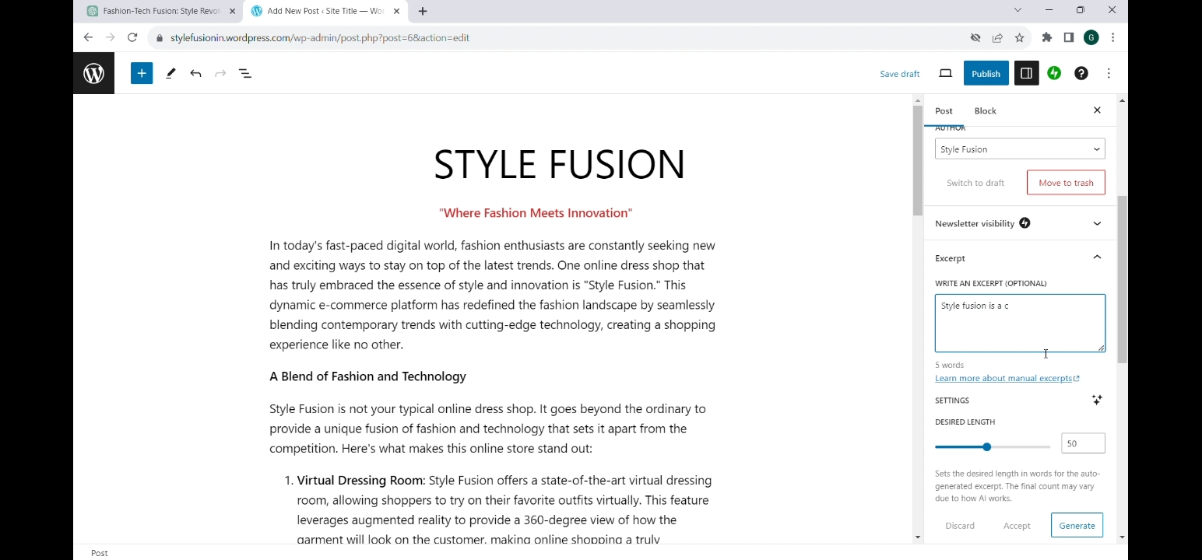

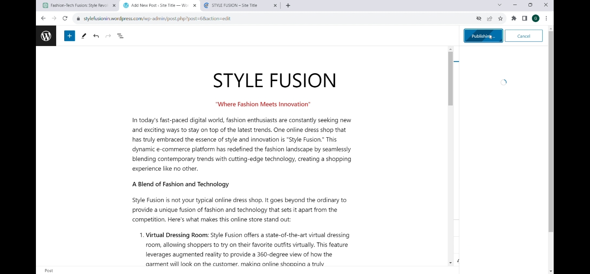

Step 13 : click view post .

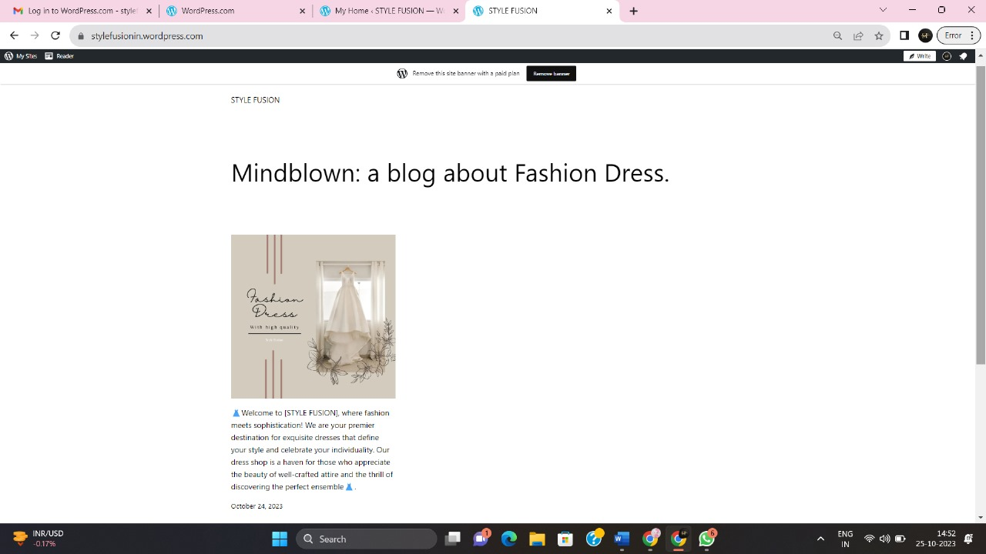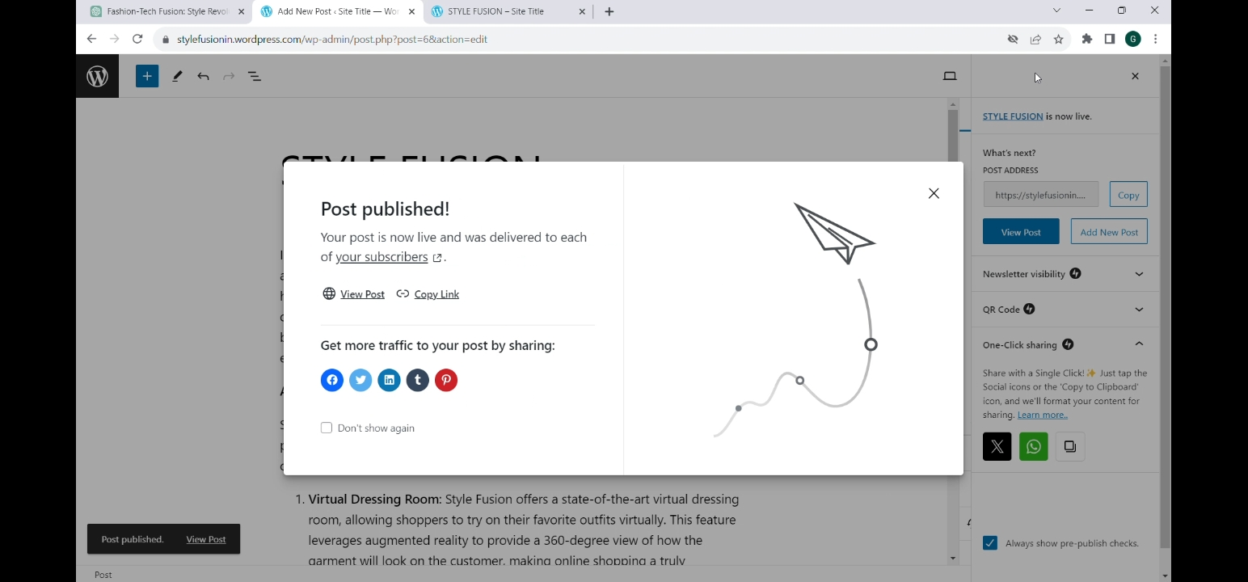

Step 14 : Here you can see the published Blog.

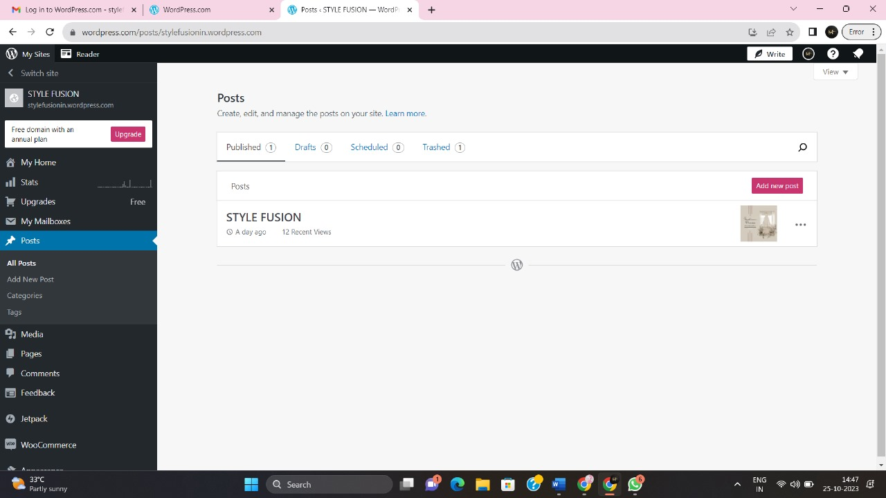

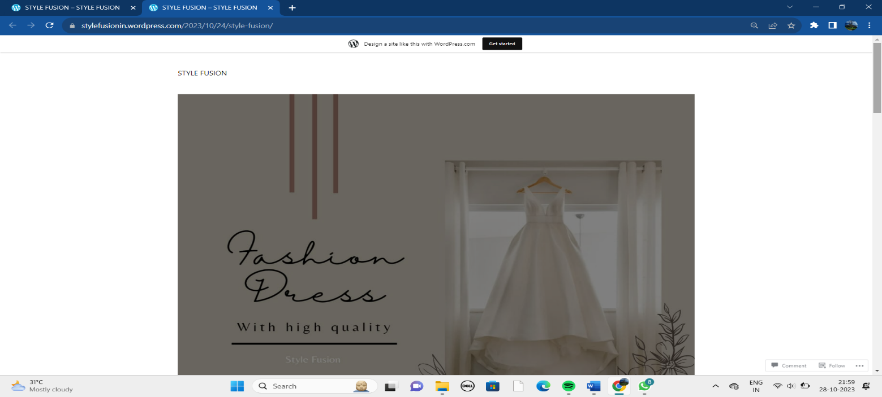

Step 15 : Link posted in social media.

